

LINDSWORTH SCHOOL

EXAMINATIONS 2025/2026
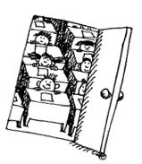

EXAM GUIDANCE

FOR

STUDENTS AND PARENTS/CARERS

CENTRE NO. 20224

School Website: www.lindsworth.co.uk

It is the aim of Lindsworth School to make the examination process as stress-free and successful as possible for all of our pupils.
The purpose of this guide is to ensure that candidates are fully briefed on the exam and assessment process in the centre and are made aware of the required JCQ awarding body instructions and information for candidates.
Hopefully the information contained in this guide will be informative and helpful to both pupils and parents/carers. Please read the guide so that you will know what is expected from pupils and the rules and regulations that every pupil needs to follow.
The awarding bodies (examination boards) and the JCQ (Joint Council for Qualifications) set particular criteria that we as a registered exam centre must follow precisely.
If you or your parent/carer have any questions at all regarding examinations please contact:
Andrew Jacques
Exams Manager & Director of Learning
The Exams Office
Lindsworth School
Monyhull Hall Road
Kings Norton
Birmingham
B30 3QA
Direct Line: 0121 693 5367

or speak to a Teacher or member of the Pastoral Staff

Remember – we are all here to help you

EXAM CONTINGENCY DAY
The awarding bodies have designated Wednesday 24th June 2026 (morning and afternoon) as a ‘contingency day’ for examinations.
The designation of a ‘contingency day’ within the common examination timetable is in the event of national or local disruption to examinations. It is part of the awarding bodies’ standard contingency planning for examinations.
All candidates MUST remain available for these dates in case of disruption to scheduled exams.
If you choose not to be available for these contingency days then you will not be eligible for any enhanced grading arrangements if brought into effect.

Along with this Exam Handbook each candidate will receive:

STATEMENT OF ENTRY
Each pupil will receive an individual Statement of Entry.
Please check the details thoroughly, including the spelling of your name and your date of birth. It can be difficult to change these details once certificates have been issued.

EXAM TIMETABLE
Each pupil will be issued with their own Examination Timetable. Your timetable is very likely to be different to other pupils’, so please do not assume that you are in the same exams as other pupils and friends.

If you lose your timetable ask for a replacement. This is not a problem. Please see Andrew Jacques (Exams Manager) or a member of the Pastoral or Teaching staff.

It is important that you refer to your timetable to make sure that you are prepared for your exams and that you know exactly when each exam is.

Yr 11 pupils will be on Study/Exam leave at some point, so they must ensure they know when they should be in school for their exams. Make sure that you leave enough time for your journey to school and arrive in good time for each exam. Aim to be early.

The whole school Examination Timetable will be available on the school’s website when finalised. This timetable will show all of the exams that are taking place during the exam period. But remember – it is unlikely that you will be in every exam listed, so refer to your individual timetable for your exams.

The Examination Boards that Lindsworth School use are:







CONTACT NUMBERS
Please check that school has an up to date contact telephone number for you.

EQUIPMENT
Pupils at Lindsworth do not need to bring any equipment with them for exams. School will provide everything candidates need for each examination.

DURING THE EXAMINATIONS

EXAMINATION REGULATIONS
At the end of this booklet you will see important Information for Candidates and notices:
- Warning to Candidates
- Unauthorised Items Poster
- Social Media
- Use of AI
- Link to - Written examinations
- Link to - Non-examination assessments
- Link to - Coursework
- Link to - Privacy Notice
- Internal Appeals Timeline

All other relevant information is available on the school website in the Exams section. www.lindsworth.co.uk
All pupils should read these documents carefully and understand that if they break any of the rules or regulations that this could lead to sanction or even disqualification from ALL examination subjects.
The school MUST abide by the rules and regulations and MUST report any breach to the Awarding Body concerned.

ATTENDANCE FOR EXAMS

Candidates are responsible for checking their own timetable and for arriving at school on the correct day at the correct time; for being prepared for their exam and for being suitably dressed in school uniform (except for Yr 11 pupils on study leave).

All morning exams start promptly at 09.30am. Afternoon exams usually start at 1.30pm but some will start earlier, please check the start times on your exam timetables.

IT IS IMPORTANT THAT YOU ARE ON TIME. DO NOT BE LATE.

Candidates that travel independently should arrive in school at least 15-20 mins before each of their exams.

Candidates that arrive late may still be admitted into the exam if it has already started; although this is not guaranteed and is dependent on availability of staff to invigilate in each particular exam instance. If you are going to be late contact school as soon as possible and let us know. We will still ask you to make your way into school as we will always try to accommodate you. If a parent / carer / adult can accompany you to school this would be helpful as we will need to submit a report to the exam board and if you have a witness to say that you did not speak to any other candidate on your way to school that is a real help.

Purpose of the candidate exam handbook

- To support/compliment candidate briefings/assemblies
- To inform candidates about malpractice in examinations/assessments
- To inform candidates about the use of their personal data and copyright
- To ensure candidates are provided with all relevant information about their exams and assessments in advance of any exams/assessments being taken
- To ensure copies of relevant JCQ information for candidates documents and exam room posters are provided in advance of any exams/assessments being taken
- To answer questions candidates may have etc.
- To inform candidates of/signpost candidates (and where relevant parents/carers) to any exams-related policies/procedures that they need to be made aware of

JCQ Information for Candidates

Malpractice

- To maintain the integrity of qualifications strict regulations are in place
- Malpractice means any act or practice which is in breach of the Regulations
- Any alleged, suspected or actual incidents of malpractice will be investigated and reported to the relevant awarding body/bodies
- JCQ provides information regarding what constitutes malpractice:
- Introduction of unauthorised material into the examination room
- Breaches of examination conditions
- Exchanging, obtaining, receiving, or passing on information which could be examination related (or the attempt to)
- Offences relating to the content of candidates’ work
- Undermining the integrity of examinations/assessments
As per regulations set out in the JCQ Instructions for Conducting Examinations 2025/2026 ICE and the Indicative sanctions against candidates (Appendix 6, Suspected Malpractice - Policies and Procedures)
Information for candidates – Social Media
Please see our Behaviour Policy and Malpractice Policy on the School website in the Exams Section

Things not to do on social media:
- Buy/ask for/share exam content
- Pass on rumours of what’s in exams
- Share your work
- Work with others so that your coursework is not your own independent work

Research and using references
...Where computer-generated content has been used (such as an AI Chatbot), your reference must show the name of the AI bot used and should show the date the content was generated. For example: ChatGPT 3.5 (https://openai.com/blog/chatgpt/), 25/01/2024. You should retain a copy of the computer-generated content for reference and authentication purposes.

Plagiarism
Plagiarism involves taking someone else’s words, thoughts, ideas or outputs and trying to pass them off as your own. It is a form of cheating which is taken very seriously...

Personal data
- The awarding bodies collect information about exam candidates
- To understand what information is collected and how it is used, you must read the JCQ Information for candidates – Privacy Notice
As per regulations set out in the JCQ General regulations 2025-2026 Refer to GR 6 and Information for candidates – Privacy Notice (also available on the school website and link at the end of this booklet)

Copyright
- The copyright of any form of work created by a candidate that is submitted to an awarding body for assessment (referred to as Assessment Materials) belongs to the candidate
- By submitting this work, a candidate is granting the awarding body a non-exclusive, royalty-free licence to use their assessment materials (referred to as Assessment Licence)
- If a candidate wishes to terminate the awarding body’s rights for anything other than assessing his/her work, the awarding body must be notified by the centre and it is at the discretion of the awarding body whether or not to terminate such rights
As per regulations set out in the JCQ General Regulations 2025/26 Refer to GR 6

Coursework assessments/non-examination assessments
For some qualifications you will undertake units of assessment or coursework. Your teacher will have explained what is required for these assessments to you and how they count towards your final grade. You will take the assessments under the conditions set by the examination boards. School have to ensure that you are marked fairly and in accordance to the exam board’s requirements. Your teacher MUST advise you of the marks that they are awarding you. If you feel that the mark that you have received is incorrect, you have the right to question / appeal the mark.
In the first instance speak to your teacher as soon as possible and raise your concern. If you are unhappy about the explanation then you need to follow the procedures set out in the Internal Appeals Procedure Policy (on the school website) and Timescale diagram (shown at the end of this handbook). Speak to the Exams Manager if you need any clarification on what to do.
See – Information for Candidates – Non-examination assessment 2025-2026, Information for Candidates – Coursework 2025-2026 and Information for candidates documents on the school website exams area
The Headteacher is provided with a full report on the review of marks.
The centre will… notify candidates, including any private candidates entered through the centre, of their examination entries and the dates and times of their examinations/assessments… ensure that the JCQ Information for candidates documents (coursework, non-examination assessments, on-screen tests, privacy notice, social media and written examinations) are distributed to all candidates whether electronically or in hard copy format prior to assessments and/or examinations taking place… (Candidates must also be made aware of the content of the JCQ Unauthorised items and Warning to candidates posters. (GR 5.8)

Examination Do’s and Don’ts
Once you enter the examination room you are under formal examination conditions.
You MUST NOT attempt to communicate with or distract other pupils.

You MUST sit in your allocated seat.

ALL coats, jackets, hoodies and hats must be removed and placed in the designated area. You are not allowed to wear these in examinations.

ALL bags must be handed in.

NO food or drink is allowed into examinations. Water will be provided. If you need any specific food/drink for health reasons, please speak to the Exams Manager or your Pastoral Team.

Mobile Phones, Smart Watches devices and normal wrist watches MUST NOT be brought into the examination room. You MUST hand it in BEFORE you enter the examination room. If you are found with one in the exam, we are required to write an incident report and send it to the exam board. If you refuse to hand your device in you will be disqualified from the exam.
NO exceptions can be made. This rule also applies to any technological / web enabled item.

Candidate’s hands may be inspected to ensure that they do not have anything written on them.

DO NOT write on the examination desks. This is regarded as vandalism and we will contact your parents/carers and ask for the damage to be paid for.

DO NOT draw or write any inappropriate or offensive comments on the examination paper. If you do your paper may be void and the examination board may refuse your paper.

LISTEN carefully to the instructions that you are given.

You will be asked to check that you have the correct paper.

The school Centre Number, the date and time, the exam paper subject, reference number and allowed time will be shown in the examination room

The start and finish time will be clearly displayed

DO NOT complete any information of the front of the examination paper until you are instructed to do so by the Invigilator.
DO NOT open the question paper until you are instructed to do so.

Read ALL instructions carefully and take care to number your answers correctly.

Candidates MUST stay in each examination for at least an hour after the examination boards’ published starting times (or for the duration of the examination if less than one hour).

If you finish your paper early you should use the remaining time to read through and check your answers.

At the end of the examination ALL work must be handed in. Remember to cross out rough work. If you have used any additional answer sheets make sure that you have put your correct details on them before you hand them in. (Full name, Candidate No, and Centre No.)

Remember until you have actually left the exam room you are still under formal examination conditions and absolute silence must be maintained.

Be considerate to other pupils who are still trying to work.
If you break these rules you could be disqualified from the exam.

Any form of malpractice will be reported to the Examination Board.

Evacuation Alarm
Should the alarm sound during your exam, STOP what you are doing and LISTEN to what the Invigilator tells you.

Remain silent.

If you are required to leave the exam room you must remember that you are still under examination conditions. DO NOT communicate with any other pupils. DO NOT attempt to bring the exam paper or equipment out of the room with you.

The full evacuation regulations will be read out at the start of every exam.

Invigilators
At Lindsworth School we use our own staff to invigilate. We do not employ external staff for invigilation.

All Invigilators have been fully trained to JCQ exam rules and regulations.

Invigilators are there to support you but CANNOT help you with your exam paper.

PLEASE DO NOT ask an Invigilator to help you or discuss the exam questions you.

Pupils are expected to behave in a respectful manner to all Invigilators and follow their instructions at all times.

Remember we are here to support you but we must apply the rules and regulations when it comes to examinations.

Calculators
Lindsworth School will provide ALL candidates with a Scientific calculator for any maths or science paper where a calculator is allowed. You do not need to bring your own calculator to the exam. We will not allow you to use your own calculator

Access Arrangements
Candidates with Access Arrangements will be informed beforehand of their arrangements (and will be familiar of these arrangements from their Mock assessments). Candidates will have signed permission forms and have been issued with information sheets regarding the approved arrangements that are in place for them.

Absence from Examinations
If for any reason you are going to be absent from an exam you must inform school at the earliest possible opportunity, so that we can help and advise you on what you should do.

Only in ‘exceptional circumstances’ are candidates allowed Special Consideration for absence from exams. For these circumstances medical or appropriate evidence must be given to the school without delay. School will then have to apply for ‘Special Consideration’.

Examples: the night before the examination you are admitted to hospital, or you have received treatment from your GP for a medical issue.
You MUST provide proof from the hospital / GP that you were in hospital and / or received treatment.

A self-certification form (JCQ/ME Form 14) can be obtained from the Exams Manager which can be countersigned by the doctor, nurse or GP as evidence.

Pupils need to have completed a minimum of 25% of the specification (non-examination assessment / coursework) for school to apply for ‘Special Consideration’ on your behalf.

If you fail to attend an examination without good reason and without informing the school, Parent/Carers and candidates are reminded that school may require reimbursement for the exam entry fee.

Please see Candidate Absence Policy in the exams Section on the school website.

MISREADING YOUR TIMETABLE IS NOT CONSIDERED
OR ACCEPTED AS A SATISFACTORY REASON FOR ABSENCE

Results Day
Exam results will be available for students to collect on

Thursday 20th August 2025 from 10.00am – 12midday

There will be teaching staff, members of the Senior Leadership Team and Careers Advisers available on results day to offer support and advice.

If you do not collect your results in person on results day we will post them to you first class.

If you need someone else to collect them for you, then school must receive written permission from pupils beforehand to accommodate this request. School will not give your results to anyone else but you without this written permission.

If you wish to have your results emailed to you then you must speak to the Exams Manager. Only the pupil’s personal email will be deemed as an acceptable email address for school to send results to. Students will be issued with a password when they request email notification.

Appeals and Post Results Services
If you have any concerns regarding your results and feel that there has been a mistake with the grade you have received, in the first instance speak to one of the staff available on results day and you will be given advice on what to do next. There are different services that can be accessed. Access to Scripts, Reviews of results and Appeals.

Please see the school website for details of Access to Scripts, Reviews of results and Appeals Procedures.

PLEASE MAKE SURE YOU READ - The Complaints and Appeals Policy AND the Post Results Services information on the website www.lindsworth.co.uk in the Exams section

Also See GR 5.13 and JCQ Post Results Services Information (to be updated as soon as is available)

Examination Certificates
School receives your exam certificates at the end of October.

We will write to you to let you know when they are ready for collection. Please ensure that you inform us of any change of address. We do not post out examination certificates.

We are only required to keep your certificates for 12 months. After this time your certificates may be confidentially destroyed. Should you need copies you will then have to contact the relevant examination board and request copies; these cost approximately £35 per certificate.
Please be advised that some Awarding Bodies do not provide replacements certificates, they will only provide a Statement of results.

EXAM CHECK LIST
 | If you are not picked up from home in a School Minibus, aim to arrive at school at least 15 minutes prior to the start of an exam. It is much better to leave yourself a safety margin on timings in case of problems with the journey.
ALL bags, coats, hoodies, gloves and hats must be handed in.

NO EXCEPTIONS

 | Phones / iWatches – Students must not have these in their possession (either on or off). They must be handed in for safe keeping.  **This is very important – if a phone/iWatch is found, it is likely that you will be disqualified from the exam or from all future exams taking place that series.  This applies to any technological / web enabled item.
 | Normal wristwatches are not allowed
 | Ensure that your hands are free from any writing – they may be checked
 | All of the stationery that you will need for your exams will be provided for you.
 | In an exam where you have the use of a calculator, you should not have a calculator cover on your desk. Calculators will be provided for you.
Sshh! | There is absolutely no talking or communication between candidates once you enter the exam room. If you have any questions, you should raise your hand and an invigilator will come to you. If you are found talking to other candidates in the examination your whole exam could be cancelled.
 | Please dress sensibly for the exam. The temperature in the exam room can fluctuate enormously during the May/June time. Hats, jackets, gloves and hooded tops should not be worn.
 | No food is allowed in the exam room (if you have a special dietary requirement – please see Jo Ottley, Exams Manager or your Teacher before the exams)
 | Water will be provided for you in each exam. If you bring your own drink it must be in a clear plastic bottle without any labels on it (it will be inspected by an Invigilator), otherwise it will be taken from you and kept until the end of the exam.

Please check the school website for all of the relevant information regarding examinations.
www.lindsworth.co.uk

You must read this information:

Information for Candidates - Written Examinations 2025-2026

Information for Candidates - Coursework 2025-2026

Information for Candidates - Non examination assessments – 2025-2026

Information for Candidates - Privacy Notice – 2025-2026

(this information can also be found on the school website in the Examination Section)

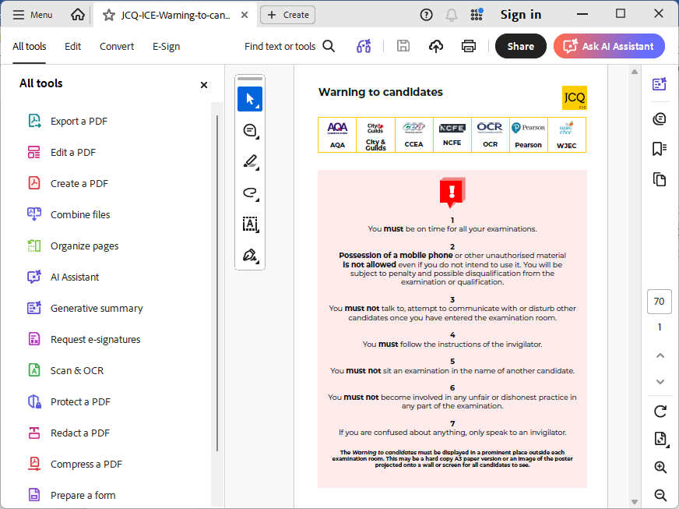
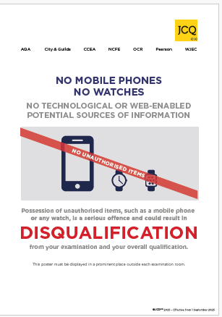

TIPS TO HELP YOU

KEEP HYDRATED – Drink plenty of water
This will help with concentration and memory

STICK TO A ROUTINE
GET GOOD SLEEP AND ENOUGH SLEEP
DON’T LET SOCIAL MEDIA AND OTHER STUFF DISTRACT YOU
AVOID JUNK FOOD AND EAT A WELL BALANCED DIET – EAT A GOOD BREAKFAST
NEVER SKIP TAKING A BREAK FROM REVISION
REWARD YOURSELF WITH MINI-TREATS – WATCH A BIT OF TV OR LISTEN TO A BIT OF MUSIC

If you are feeling worried and think you need help then speak to a member of staff.

Revision Websites

BBC Bitesize - The essential revision website. It covers all GCSE subjects, even the more obscure ones and lists every awarding body so that you can find revision info on the specification you are following at school or college. There are some brilliant short videos, online quizzes, tests and podcasts and each section comes with a glossary, so if there is a word or term you don’t understand it is there for you to check.

Studywise.co.uk – This really useful website has a section for each subject area at GCSE and A Level and includes links for each one to more specific sites focusing on revision notes, quizzes, forums, revision books/guides and importantly, specimen and past papers from each awarding body. There is also a “study shop” where you can buy revision essentials such as flash cards and view recommended Amazon products.

Quizlet.com – This website contains huge amounts of resources including diagrams and quizzes and allows you to create your own content to share with others. It aims to make learning fun by using games and interactive features to engage learners. You can also download an app for learning on the go.

Get Revising – A brilliant online tool for creating your own personal revision timetable. You can even add reminders and it is very easy to update to fit in with any changes you need to make.

y aw

This page has purposely been left blank

GOOD LUCK
Remember – we are here to support and help you.

EXAMINATION RESULTS DAY
Exam results will be available for students to collect on
Thursday 20th August 2025 from 10.00am – 12midday

